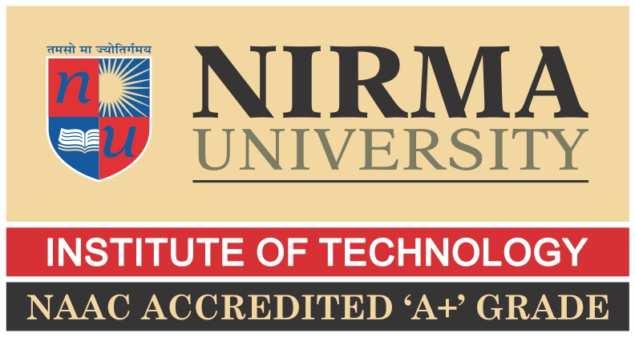

Prepared and present by :

KHUSH PITHVA 24BCE174

PARTH SAVALIYA 24BCE167

PRIYANSH PATEL 24BCE180

Mid-Day Meal and the Right to Nutrition: A Constitutional and Social Perspective

Ensuring Health, Dignity, and Equity Through School Nutrition
Created by: Khush Pithva (24BCE174)
Image Suggestion: School children enjoying their mid-day meal in a cheerful school environment

Part 1: The Story Behind the Mid-Day Meal Scheme

Introduction
Hunger and education are deeply connected. A hungry child cannot concentrate, learn effectively, or participate fully in school activities. For millions of children in India, hunger once stood as the biggest barrier to education. Recognizing this, the Government of India introduced the Mid-Day Meal Scheme (MDMS) — one of the world’s largest school feeding programs.
The scheme’s primary purpose is not only to satisfy hunger but also to promote nutritional well-being, school attendance, and social equality. It aims to ensure that no child is deprived of education because of an empty stomach. By linking food with education, the MDMS contributes to two of the most vital Sustainable Development Goals (SDGs): Zero Hunger (SDG 2) and Quality Education (SDG 4).
Nutrition plays a foundational role in a child’s physical and mental development. Lack of adequate nutrition can impair learning abilities, weaken immunity, and limit future productivity. The Mid-Day Meal Scheme thus represents a bridge between education policy and public health policy, uniting both in the service of child welfare.

Historical Background
The roots of the Mid-Day Meal Scheme go back almost a century.
- 1925: The idea originated in Tamil Nadu (then Madras Presidency), which started providing cooked meals to poor children in select municipal schools. This was the first organized attempt in India to combine food with education.
- 1956–1980s: Various states such as Gujarat, Kerala, and West Bengal adopted similar initiatives at the local level. However, these remained limited in coverage.
- 1995: The central government launched the National Programme of Nutritional Support to Primary Education, which marked the beginning of a nationwide school feeding program. Initially, this was in the form of dry rations (grains given to take home).
- 2001: A landmark Supreme Court judgment transformed the scheme by directing all states to serve hot cooked meals in schools instead of distributing dry rations.
- 2004: Specific nutritional norms were formalized to ensure that meals met minimum calorie and protein requirements.
- 2006: The scheme was extended to cover upper primary students (Classes VI–VIII).
- 2013: Under the National Food Security Act (NFSA), the scheme became a legal right for all children aged 6–14 years in government and government-aided schools.
- 2021: It was renamed PM POSHAN (Pradhan Mantri Poshan Shakti Nirman), expanding its vision and reach.

Objectives of the Scheme
The Mid-Day Meal Scheme is guided by multiple goals that go far beyond food provision:
- Nutritional Improvement: To combat malnutrition and ensure that every child receives at least one nutritious meal each school day.
- Educational Advancement: To improve school enrollment, attendance, and retention, particularly among economically and socially disadvantaged groups.
- Social Equity: To foster social harmony by allowing children from all backgrounds—caste, class, and religion—to share the same meal.
- Gender Equality: To encourage the education of girls by reducing gender disparities in school attendance.
- Community Development: To create employment opportunities for local women and self-help groups through food preparation and distribution.

Timeline of Key Milestones
Year | Event
1925 | Mid-Day Meal introduced in Tamil Nadu
1995 | Nationwide launch as NP-NSPE
2001 | Supreme Court mandates hot cooked meals
2004 | Nutritional norms established
2006 | Expansion to upper primary students
2013 | NFSA gives meals legal status
2021 | Rebranded as PM POSHAN

Part 2: The Current Scenario

Scope and Reach Today
The Mid-Day Meal Scheme has grown into the largest school nutrition program in the world.
As of 2022–23, it reached nearly 12 crore children across 11.5 lakh schools in India.
Target Group:
- Children aged 6–14 years studying in Classes I–VIII in government, government-aided, and local body schools.
- Madarsas and Maqtabs recognized under the scheme are also included.

Implementation and Funding
The scheme operates on a joint partnership model between the Central and State Governments.
- The Central Government provides food grains, cooking cost support, and administrative assistance.
- The State Governments manage local logistics, kitchen construction, and staff honorariums.
- Meals are cooked on school premises to ensure freshness and safety.
- Teachers, local women’s groups, and non-governmental organizations (NGOs) play vital roles in supervision and management.
NGOs such as Akshaya Patra Foundation have developed large-scale, hygienic kitchen models that serve millions of meals daily, setting benchmarks for quality and efficiency.

Nutritional Standards and Menu
Prescribed Nutritional Content:
Category | Calories | Protein
Primary (Classes I–V) | 450 kcal | 12 grams
Upper Primary (Classes VI–VIII) | 700 kcal | 20 grams
Sample Weekly Menu:
Day | Menu Example
Monday | Rice, dal, seasonal vegetable curry
Tuesday | Wheat khichdi, chana, fruit
Wednesday | Rice, sambhar, boiled egg or banana
Thursday | Pulao with soybean, salad
Friday | Rice, mixed vegetable curry
Saturday | Rice, dal, curd
Several states have introduced fortified rice, salt, or oil to tackle micronutrient deficiencies such as anemia and vitamin deficiency.

Achievements and Impact
- Improved Enrollment and Retention:
The scheme has successfully increased school attendance, especially among children from poor and marginalized backgrounds.
- Nutritional Benefits:
Studies indicate significant reductions in undernutrition, stunting, and anemia among children receiving regular mid-day meals.
- Promotion of Social Equity:
Children from diverse social and economic groups eat together, helping to reduce traditional caste and community barriers.
- Women Empowerment:
The scheme has generated employment for millions of women as cooks and helpers, strengthening local economies.
- Educational Impact:
Teachers have observed better attention spans and energy levels in classrooms, leading to improved academic engagement.

Challenges and Limitations
Despite its success, several challenges continue to affect implementation:
- Quality and Hygiene Issues: Inadequate kitchen facilities or unsafe cooking environments in some schools.
- Leakages and Corruption: Occasional diversion of funds or poor monitoring.
- Nutritional Imbalance: Menus in some areas lack diversity and micronutrient content.
- Pandemic Disruptions: COVID-19 school closures interrupted meal distribution; many states shifted to dry rations or cash transfers.
- Irregular Supply Chains: Delays in food grain delivery and insufficient cooking cost support.

Suggestions for Improvement
- Introduce real-time digital monitoring systems to ensure transparency and timely delivery.
- Conduct regular quality checks and third-party audits.
- Improve infrastructure, including kitchen sheds, clean utensils, and safe drinking water.
- Provide training programs for cooks and helpers on hygiene, nutrition, and safety.
- Encourage community participation and social audits to increase accountability.

Part 3: Constitutional Relevance

Right to Nutrition and the Indian Constitution
India’s Constitution emphasizes human dignity and the right to live a life free from hunger and deprivation.
- Article 21: Protects the Right to Life, which the Supreme Court has interpreted to include the Right to Food and Nutrition.
- Article 47: A Directive Principle of State Policy that directs the State to raise the level of nutrition and improve public health.
The Supreme Court’s 2001 order in the PUCL v. Union of India case gave constitutional strength to the Mid-Day Meal Scheme, transforming it into a justiciable right rather than a welfare policy.

Directive Principles and Legislative Support
- Article 39(e) & (f) – Ensure that children are not abused and have opportunities for healthy development.
- Article 45 – Mandates early childhood care and education until the age of six.
- National Food Security Act (2013) – Recognized mid-day meals as a statutory right for children aged 6–14 years.
Under the NFSA, School Management Committees (SMCs) are responsible for ensuring food quality, quantity, and regular delivery. This law effectively made access to nutrition a legal entitlement, not just a government scheme.

Judicial Oversight and the Role of PILs
The judiciary has played an active role in ensuring implementation through continuous monitoring of the Right to Food cases. The Supreme Court Commissioners on the Right to Food have regularly reported on the progress and issues of the scheme, ensuring government accountability.
Through these interventions, the Court has reaffirmed that food security and nutrition form an integral part of the Right to Life with Dignity.

Part 4: Conclusion and Future Vision

Success Stories
- Tamil Nadu: The pioneer in mid-day meals, now expanded to include breakfast programs for younger children.
- Odisha: Introduced millet-based meals to promote local agriculture and improve nutrition.
- Kerala: Known for decentralized cooking, strict hygiene norms, and nutrition awareness.
- NGOs like Akshaya Patra: Serve millions of students daily through centralized kitchens using modern technology and logistics systems.

Suggestions for the Future
- Enhanced Monitoring: Strengthen the use of mobile-based monitoring applications for transparency.
- Nutritional Diversification: Include regionally available grains, pulses, and vegetables to ensure balanced nutrition.
- Community Involvement: Encourage parents and local bodies to participate in meal supervision.
- Education Integration: Introduce lessons on nutrition and hygiene in the school curriculum.
- Expansion: Extend the scheme to cover pre-primary and high school students in economically weaker areas.

Conclusion
The Mid-Day Meal Scheme is more than a welfare initiative—it is a promise of equality and dignity for every child. By nourishing the body, it nurtures the mind; by ensuring attendance, it strengthens the future of the nation.
It is one of India’s most successful examples of how social welfare, education, and public health can come together to create lasting impact. With consistent implementation, improved infrastructure, and community participation, this scheme can ensure that no child in India ever learns on an empty stomach.
As the Kothari Commission rightly observed:
“The destiny of India is being shaped in her classrooms.”
Let those classrooms be places of learning, health, and hope.

